Student Name: ______________________________________ Date: _____________ Graduation Year: __________________________

CHS GRADUATION CHECKLIST

- Options to earn your CHS High School Diploma:

Option #1: | Option #2: | Option #3:
24 Credit track - requires sixteen (16) core academic credits and eight (8) credits in Electives. | 18 Credit ACCEL track - Academically Challenging Curriculum to Enhance Learning - requires the same courses as the 24 Credit track except a student only needs three (3) electives and HOPE is not required. | Advanced International Certificate of Education (AICE) track – requires seventeen (17) core academic credits, three (3) credits of world language, three (3) additional AICE, AP and/or Dual Enrollment credits of choice and one (1) additional credit of elective.
All options require a 2.0 Cumulative unweighted GPA and passing test scores for Reading and Math (see below)

- Testing Requirements Note: the requirements listed below apply to student who entered 9th grade in 2020 and beyond.

- Reading: Earn a passing score on the 10th grade FSA ELA or a minimum concordant score on SAT Evidence-Based Reading and Writing section (480), an average of ACT Reading and English (18) or CLT Verbal Reasoning and Grammer/Writing combined score (36).

- Math: Earn a passing score on the Alg 1 EOC, or a minimum concordant score on the Geometry EOC (499), SAT Math (420), ACT Math (16), CLT Quantitative Reasoning (11) or PSAT Math (430).

- Credit Requirements for Option #1 and Option #2 (Option #3 is on back)

English (4 credits)
______ ______ English - credit 1
______ ______ English - credit 2
______ ______ English - credit 3
______ ______ English - credit 4

Mathematics (4 credits)
______ ______ Algebra I
______ ______ Geometry
______ ______ Math - credit 3
______ ______ Math - credit 4

Science (3 credits)
______ ______ Biology
______ ______ Science - credit 2
______ ______ Science - credit 3

Social Studies (3 credits)
______ ______ World History
______ ______ U.S. History
______ Economics (one semester)
______ U.S. Gov (one semester)

Performing, Fine Practical Arts or Career Tech (1 credit)
______ ______ Art, Band, Drama, Chorus, Digital Info
Tech, TV Production, Woodshop, Etc.

Physical Education (1 credit)
______ ______ Hope – not required if you are selecting
option #2. (Waivers can be obtained by completing two credits of JROTC or participating on an interscholastic sports team at CHS for two seasons)

Electives (8 credits needed for option #1)
(3 credits needed for option #2)
______ Personal Financial Management
*Students that start H.S. in 23/24 or later must complete Personal Financial Management (0.5 credit) as part of their required electives.

State Assessments
______ Passing score on Grade 10 FSA ELA or equivalent.
______ Passing score on Algebra 1 EOC or equivalent.

Grade Point Average (must be 2.0 or above)
______ GPA

- District and School Expectation (successfully complete at least one below): All student will Graduate with a College and/or Career Acceleration option:

______ Earned an Industry Certification (ex: ESB)
______ Earned a passing score on am AICE/AP exam.
______ Passed a Dual Enrollment class with a C or better.
- University Admissions/Bright Futures Requirements: In addition to the standard high school core graduation requirements, Universities admissions and Bright Futures also require 2 credits of a world language. The 2 credits must be in the same language.

______ ______ World Language - credit 1
______ ______ World Language - credit 2

Student Name: ______________________________________ Date: _____________ Graduation Year: __________________________

- Credit Requirements for Option #3 (AICE)
Note: this curriculum sequence is only for students who have enrolled in our Cambridge district application program. Completion of this sequence will result in earning your CHS diploma. Earning your AICE diploma will be determined by your results on your AICE exams.

English (4 credits)
______ ______ AICE English General Paper
______ ______ AICE English Language
______ ______ English - credit 3
______ ______ English - credit 4

Mathematics (4 credits)
______ ______ Algebra I
______ ______ Geometry
______ ______ Math - credit 3
______ ______ Math - credit 4

Science (4 credits)
______ ______ Biology
______ ______ Science - credit 2
______ ______ Science - credit 3
______ ______ Science - credit 4

Social Studies (4 credits)
______ ______ World History
______ ______ U.S. History
______ ______ Economics
______ ______ U.S. Gov / Personal Finance
*Students that start H.S. in 23/24 or later must complete Personal Financial Management (0.5 credit) as part of their required electives.
Global Perspectives (1 credit)
______ ______ AICE Global Perspectives

World Language (3 credits)
______ ______ World Language - credit 1
______ ______ World Language - credit 2
______ ______ World Language - credit 3

AICE, AP or Dual Enrollment Electives (3 credits)
______ ______ Advanced Elective – credit 1
______ ______ Advanced Elective – credit 2
______ ______ Advanced Elective – credit 3

Other Electives (1 credit)
______ ______ Practical, Performing or Fine Art course

State Assessments
______ Passing score on Grade 10 FSA ELA or equivalent.
______ Passing score on Algebra 1 EOC or equivalent.

Grade Point Average (must be 2.0 or above)
______ GPA

Earning an AICE Diploma

Earning an AICE diploma is not the same as earning your CHS high school diploma. They are two separate diplomas.

A CHS high school diploma is earned by completing the curriculum requirements of option 1, 2 or 3 as described on the front side of this document.

To earn an AICE diploma, students must pass seven credits worth of AS or A Level examinations. At least one examination must come from each of the three subject groups: Mathematics and Sciences, Languages, and Arts & Humanities. One credit must come from “Core” which is AS Global Perspectives course.
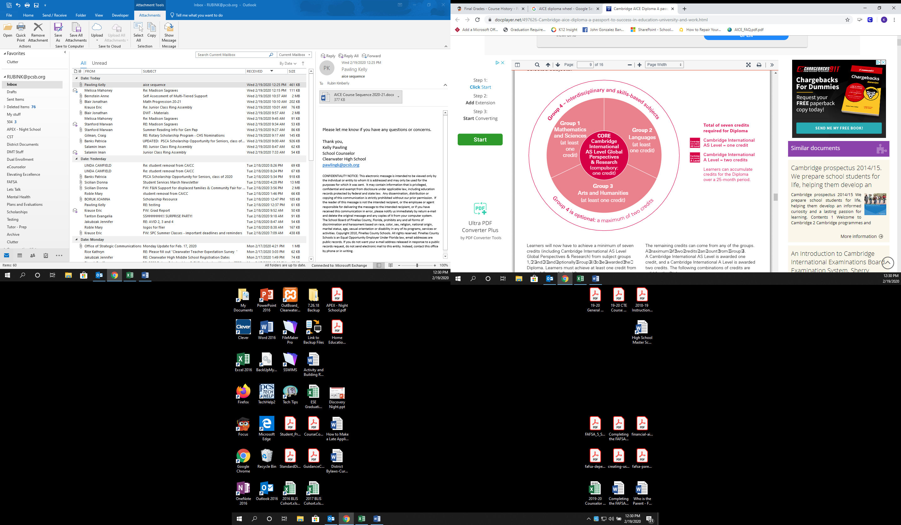

Core: Global Perspectives
- AS Global Perspectives & Research

Group 1: Mathematics & Science
- AS Biology
- AS Chemistry
- AS Environmental Management
- AS Marine Science
- AS Psychology

Group 2: Languages
- AS/A English Language
- AS Spanish Language

Group 3: Arts & Humanities
- AS & AL Art & Design
- AS Computer Science
- AS Economics
- AS/A English Literature
- AS/A History
- AS/A Media Studies
- AS Psychology
- AS Sociology
- AS Travel and Tourism
- AS Drama

Group 4: Interdisciplinary &
Skills Based (optional)
- AS Thinking Skills
- AS English General Paper

